IR Assignment 2 – Niveditha and Diya

Testcase1:

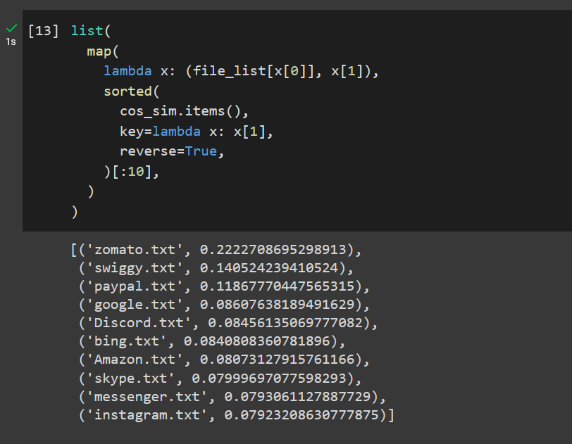

Testcase 2:

